The Ministry of Trade and U.S. Mission in Türkiye invites you to join a webinar to learn about the latest U.S. government programs in support of Türkiye’s telecom infrastructure development.  Representatives of the [International Development Finance Corporation](https://www.dfc.gov/) (DFC), the [U.S. Export-Import Bank](https://gcc02.safelinks.protection.outlook.com/?url=https%3A%2F%2Fwww.exim.gov%2F&data=05%7C01%7CYasue.Pai%40trade.gov%7Cdb7613d840c84c60e10708dbe9d25d9b%7Ca1d183f26c7b4d9ab9945f2f31b3f780%7C1%7C0%7C638360861952946738%7CUnknown%7CTWFpbGZsb3d8eyJWIjoiMC4wLjAwMDAiLCJQIjoiV2luMzIiLCJBTiI6Ik1haWwiLCJXVCI6Mn0%3D%7C3000%7C%7C%7C&sdata=DmccgVtaGtXT4GO7dlgm9pZiGoRKGRJ5DzQblo8S%2BYw%3D&reserved=0) (EXIM), the [National Telecommunications and Information Administration (NTIA)](https://www.ntia.gov/), and [U.S. Trade and Development Agency](https://gcc02.safelinks.protection.outlook.com/?url=https%3A%2F%2Fwww.ustda.gov%2F&data=05%7C01%7CYasue.Pai%40trade.gov%7Cdb7613d840c84c60e10708dbe9d25d9b%7Ca1d183f26c7b4d9ab9945f2f31b3f780%7C1%7C0%7C638360861952946738%7CUnknown%7CTWFpbGZsb3d8eyJWIjoiMC4wLjAwMDAiLCJQIjoiV2luMzIiLCJBTiI6Ik1haWwiLCJXVCI6Mn0%3D%7C3000%7C%7C%7C&sdata=NiZphshTZUGBMUaScyfz%2FkA9%2BuH9HmatHkKyY7o31P8%3D&reserved=0) (USTDA) will present on grant programs and lending facilities that can raise project success rates.

*When:*  *July 17, 3:30pm-4:45pm (Istanbul time)*

*Where:*  *Virtual Platform – MS Teams*

*Who should join:*  *Turkish companies involved in telecommunications infrastructure buildout, and U.S. companies pursuing projects and tenders in Türkiye.*

This webinar is an opportunity for Turkish telecommunications technology software and hardware providers to learn about the latest USG funding options for next generation telecommunication infrastructure buildout. Representatives from DFC, EXIM, NTIA, and USTDA will discuss who qualifies for these programs, how to access the programs, and more.

[Click here to register for this webinar](https://events.gcc.teams.microsoft.com/event/882095ef-35c9-44b7-944c-b84afb51cb92@a1d183f2-6c7b-4d9a-b994-5f2f31b3f780)

**Agenda**

**3:30 p.m.** **Welcome Remarks from Ministry of Trade and U.S. Commercial Service**

**3:37 p.m.** **Moderator Introduce Speakers**

**3:40 p.m.** **International Development Finance Corporation (DFC)**

**Brian Whitesides, Director, Office of Infrastructure**

*Long term financing options for telecom infrastructure development*

**The Export-Import Bank of the United States (EXIM)**

**Benjamin Todd, Vice President, Global Business Development**

*Long term financing options for telecom infrastructure development*

**National Telecommunications and Information Administration (NTIA)**

**Richard Upchurch, Research and Public Policy Associate**

*Overview of NTIA's Public Wireless Supply Chain Innovation Fund*

**United States Trade and Development Agency (USTDA)**

**Gokce Tuncer, Türkiye Country Representative**

*Project grants for feasibility studies, pilots, and reverse trade missions related to next generation telecommunications infrastructure development*

**4:30 p.m.** **Q&A**

**4:45 p.m.** **Webinar concludes**

**Bios**

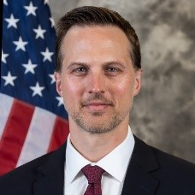

**Brian Whitesides**

**Director of the Office of Infrastructure, International Development Finance Corporation (DFC)**

Brian Whitesides is a Director in DFC’s Office of Infrastructure. In this role, he is responsible for leading the origination of international project finance transactions across the infrastructure market, to include telecommunications (fiber, mobile networks, and data centers), transport, and financial institution transactions. Prior to DFC, he worked at PwC’s capital projects and infrastructure group and for a large renewable energy developer.

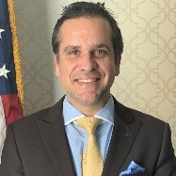

**Benjamin Todd**

**Vice President of Global Business Development, U.S. Export-Import Bank (EXIM)**

Benjamin Todd is the Vice President for Global Business Development at the Export-Import Bank of the United States (EXIM).  In this capacity, Ben is responsible for the overall function of the office as well as early-stage transaction development, marketing, and outreach efforts to potential EXIM clients, globally.  Prior to EXIM, Ben was Principal Business Development and Acting Head of Office, North America, at the European Bank for Reconstruction and Development (EBRD) where he provided early transaction development, education, and outreach to North American clients looking to invest in EBRD regions resulting in nearly €150 million in transactional development.  Prior to EBRD, Ben worked on the EMEA portfolio at EXIM where he brought in nearly $4 billion of transactions for the bank.  Ben has a master’s degree from Carnegie Mellon University and a bachelor’s degree from Trinity College, Hartford.

**Richard Upchurch**

**Policy Director, National Telecommunications and Information Administration (NTIA)**

Richard Upchurch is the Policy Director for NTIA's Public Wireless Supply Chain Innovation Fund. Previously, Richard was a member of the public policy team at Viasat, a satellite communications company, where he helped advance the company’s regulatory and government affairs agenda. Before Viasat, Richard was a consultant at Access Partnership, where he advised a broad range of private and public sector clients on public policy risks and opportunities related to 5G, cyber and supply chain security, privacy and data protection, and satellites. Richard received his M.A. in International Relations from the Johns Hopkins School of Advanced International Studies (SAIS) and his B.A. in Asian Studies from Furman University. He was born and raised in Mobile, Alabama and has been living and working in Washington, DC since 2014.

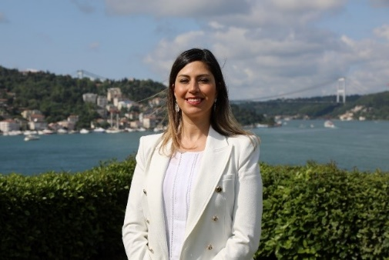

**Gökçe Tuncer Topdağı**

**Türkiye Country Representative, United States Trade and Development Agency (USTDA)**

Since November 2023, Ms. Tuncer has served with USTDA as Türkiye Country Representative. In this role, she is responsible for business development and supervision of USTDA activities in Energy, ICT, Healthcare, and Transportation sectors. Prior to joining USTDA, Ms. Tuncer served for 10 years with the Commercial Service at the U.S. Consulate General in Istanbul where assisted U.S. companies in entering or expanding into the information and communication technologies market in Türkiye. Ms. Tuncer was also the local lead of Marmara Region of Türkiye for the SelectUSA program, which supports FDI into the United States. Between 2011-2013, she worked on the Istanbul 2020 Olympic Bid Committee as a project manager. She was instrumental in preparation of the bid books and associated marketing activities. Ms. Tuncer holds a BA in English and French from Bilkent University and an MA from UCLA. She is married and has a daughter.